**Team :**

* Gaurav
* Veronica
* Gym

**Date** : 08/01/2020

_________________________________________________________________________

**Team Name: Argahanite**

Problem Based Learning Questions

Q1. Define what’s the problem statement i.e. the business case or problem-based learning project

* Due to their **continued growth**, lending to expansion into the digital space, WWI is prepared to innovate by taking advantage of their omni-channel strategy and increased variety and amount of valuable data.
* Challenges to address:
  + Increased consumer demand, leading to increased app data.
* Each **interface**, retail store, web store and mobile store, each had **their own set of service layers and databases**, resulting in siloed data and insights.
* Their biggest concerns with this approach are the **amount of time to put such a system in place and properly maintain it**, but even more so, having an inherent delay between when new data is written to the **source system** and when that data is **moved into the data warehouse**.
* There are times when they would like to move data into storage to **provide denormalized and aggregated representations of their data for reporting purposes**.
* Like to use **transmitted (unorganized) sensor data** from these trucks **to predict when a battery will most likely fail** to **reduce downtime** and **cut waste** resulting from fixed battery replacement schedules.

Q2. What do we know?

• WWI have **considered** **the usage of**a **usual** **information** warehouse to **join** **information** from their disparate **systems** to **attain** insights in one location.

• With this expansion, they have generated a **substantial** **quantity**of **extra**data, and **information** formats.

• These new **systems** **have been** **added** **barring**integrating into the OLTP **system** **facts** or Business Intelligence infrastructures.

• As a result, "Silos" of **information** **shops**have developed.

• As a first step, WWI's **technology** **crew**has **diagnosed** they **ought to** **address** the **fact** that they have **rapidly**outgrown their **capability** to **cope with** data.

• Prior to **expanding** to their **current** omni-channel strategy, WWI had a **simple** Point of Sale **utility**that **handled** **purchaser** orders at **every**retail store. They had designed their **systems** and tuned them to **cope with** this **level** of data.

Q3. List and rank possible solutions

* Scale records systems to attain greater consumers.
* Unlock enterprise insights from a couple of sources of structured and unstructured data.
* Apply deep analytics with high-performance responses.
* Infuse AI into apps to actively engage with customers.

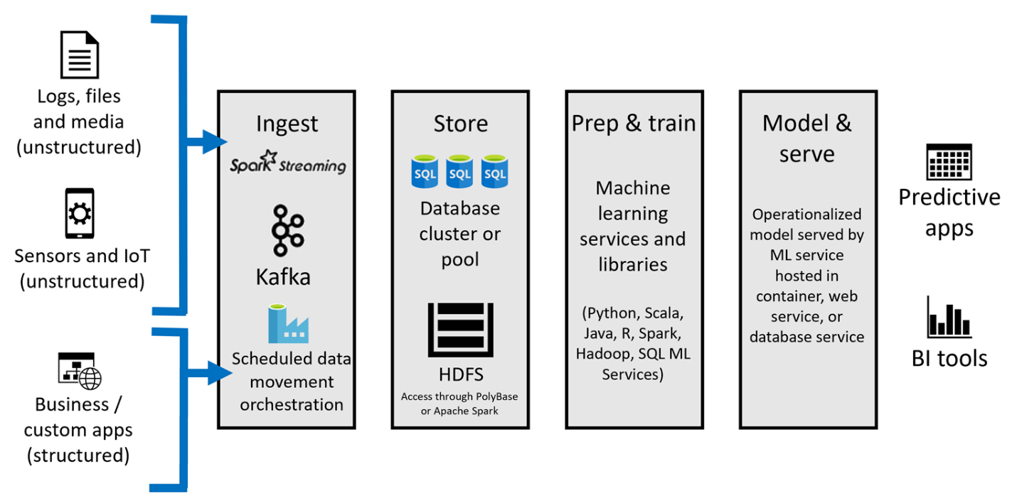

Q4. Break steps into timelines - High Level Project Board and RACI

Project Board (High Level)

|  |  |  |  |  |
| --- | --- | --- | --- | --- |
|  | Phase 1: Discovery | Phase 2:  Design | Phase 3: Development | Phase 4: Deployment |
| Timeline | From : 08/03  To: 08/21 | From : 08/21  To: MM/DD | From : MM/DD  To: MM/DD | From : MM/DD  To: MM/DD |
| Activities | 1. Understand the context of client partner project or business case . 2. Research and gather the relevant information & logic building solutions in scrums. 3. Connect with education sponsor and mentor. | 1….  2….  3…. | 1….  2….  3…. | 1….  2….  3…. |
| Deliverables | 1. Documenting and submitting the proposed solution. 2. Rehearsing in the meeting with mentor. | 1….  2….  3…. | 1….  2….  3…. | 1….  2….  3…. |

Description with Role Accountability Consult Inform (RACI)

|  |  |  |  |  |  |
| --- | --- | --- | --- | --- | --- |
| # | Phase | Description of activity | Assigned | Due Date | Status |
| 1. | 1 | Understand the context of client partner project or business case . | GS | 18th Aug 2020 | complete |
| 2. | 1 | Research and gather the relevant information & logic building solutions in scrums. | GS | 21st Aug 2020 | pending |
| 3. | 1 |  |  |  |  |
| 4. | 2 |  |  |  |  |
| 5. | 2 |  |  |  |  |
| 6. | 2 |  |  |  |  |
| 7. | 3 |  |  |  |  |
| 8. | 3 |  |  |  |  |
| 9. | 3 |  |  |  |  |
| 10. | 4 |  |  |  |  |
| 11, | 4 |  |  |  |  |
| 12. | 4 |  |  |  |  |

Q5. What we don’t know?

* + Which technology to use for ingesting data Spark Streaming / Kafka / Azure.
  + Implementing Learning Lab.
  + Using Alteryx to propose a streamlined solution.
  + Machine learning library / languages like Python, Scala, R, Java, Hadoop, SQL, ML Studio.
  + In what ecosystem Mentor recommends us to create a learning / practice curve.

Q6. List how to get missing info

* + Alteryx Starter kit for Microsoft.
  + Microsoft Learn.
  + LinkedIn Learning.